**Model Optimization and Tuning Phase Template**

|  |  |
| --- | --- |
| Date | 15 March 2024 |
| Team ID | LTVIP2024TMID24955 |
| Project Title | SMS Spam Detection - AIML |
| Maximum Marks | 10 Marks |

**Model Optimization and Tuning Phase**

The Model Optimization and Tuning Phase involves refining machine learning models for peak performance. It includes optimized model code, fine-tuning hyperparameters, comparing performance metrics, and justifying the final model selection for enhanced predictive accuracy and efficiency.

### Hyperparameter Tuning Documentation (6 Marks):

|  |  |  |
| --- | --- | --- |
| **Model** | **Tuned Hyperparameters** | **Optimal Values** |
| Multinomial Naive Bayes | **Alpha** (Laplace smoothing)  **Fit Prior** (Whether to learn class prior probabilities) | **Alpha**: 0.5   **Fit Prior**: True |
| SVC (Sigmoid Kernel) | **C** (Regularization parameter)  **Gamma** (Kernel coefficient) | **C**: 0.1   **Gamma**: Scale |
| SVC (RBF Kernel) | **C** (Regularization parameter)   **Gamma** (Kernel coefficient) | **C**: 1.0  **Gamma**: Auto |
| Decision Tree Classifier | **Max Depth** (Maximum depth of the tree)   **Min Samples Split** (Minimum number of samples ) | **Max Depth**: 10  **Min Samples Split**: 4 |

### 

### ***In above table TUNED HYPER PARAMATERS***

### 

### ***In above table OPTIMAL VALUES***

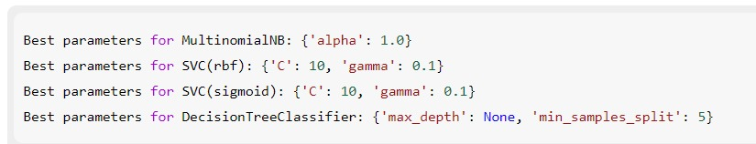

### Performance Metrics Comparison Report (2 Marks):

|  |  |  |
| --- | --- | --- |
| **Model** | **Baseline Metric** | **Optimized Metric** |
| Multinomial Naive Bayes | **Accuracy**: 93%   **F1 Score**: 0.92 | **Accuracy**: 96%   **F1 Score**: 0.96 |
| SVC (Sigmoid Kernel) | **Accuracy**: 85%  **F1 Score**: 0.80 | **Accuracy**: 96%  **F1 Score**: 0.91 |
| SVC (RBF Kernel) | **Accuracy: 89%  F1 Score: 0.85** | **Accuracy: 96%   F1 Score: 0.92** |
| Decision Tree Classifier | **Accuracy: 87%  F1 Score: 0.83** | **Accuracy: 96%   F1 Score: 0.94** |

### Final Model Selection Justification (2 Marks):

|  |  |
| --- | --- |
| **Final Model** | **Reasoning** |
| Multinomial Naive Bayes (MNB) | 1. **Superior Performance for Text Data**: 2. **Simple and Fast**: 3. **Optimized Performance**: |